Feather collection protocol for burrowing owls

The purpose of collecting feathers is to determine the amount of exchange between populations. This will ultimately help test our hypothesis that burrowing owls that formerly migrated between Mexico and Canada/northern U.S. are altering their migratory habit and becoming year-round residents in low-elevation areas throughout the southwest.

We need feather samples from both adults and juvenile owls; feathers from juveniles will allow us to identify the local isotope “signature” from each location, and then we will be able to use the signatures from each area to determine where the feather from each adult was grown (and hence where it spent the previous breeding season). The more samples we get from each location, the better able we will be to determine the origin of each individual adult owl.

For juveniles: collect 3 body feathers from the breast and 3 body feathers from the back. Use one hand to stabilize (hold down) the skin around the feathers. Use the other hand to pinch 3 feathers at the base of the feather between your thumb and index finger and pull slowly and firmly until the feathers come out.

For adults: collect 3 body feathers from the breast and 3 body feathers from the back, 1 full tail feather (3rd from right), and ≥1 feather from the head. If you are holding the owl in your lap with the owl’s belly facing up and the owl’s feet pointing toward you, spread the tail and with one hand, and with the other hand place your thumb and index finger on either side of the third tail feather in from the furthest left (third rectrix on the bird’s right side). Once you have the tail feather with one hand, use the other hand to stabilize (hold down) the skin around the feather. Then pull the feather at the base where it inserts into the skin. Pull slowly and firmly until the feather comes out of the skin. Then collect at 3 body feathers from the breast, 3 from the back, and at least one from the head. For each of these, pinch the base of the feather(s) and pull firmly and slowly while stabilizing the skin around the feathers with the other hand.

For recaptures of previously banded adult owls: If the owl was banded in a prior year, collect the third tail feather on the right and body feathers from 3 different areas as described above. These are important feathers because they allow us to verify the validity of the stable isotope results. If the owl was banded earlier the same year and a feather sample was already taken, look to see whether the owl has started to regrow the collected feather and record the growth status of the 3rd-from-the-right tail feather (ie, “~65% regrown”).

Put the feather(s) in a feather envelope (e.g., Columbian #3 Coin Envelopes, 2½” x 4¼”, Mfr# CO545, Office Depot Item # 348-177) and label the outside of the envelope with the following information:

# and type of each feather (adults: # partial tail, # whole tail, # body feathers, # head feathers; juvies: # of body feathers)

USFWS Band #:
ACRAFT Band #:
Date:
Age (HY, AHY, or “unknown age”):
Sex (M, F, M?, F?, or “unknown sex”):
Nest identification #:
Location/study site:
State:
Recapture or New Capture:
Collector’s full name:
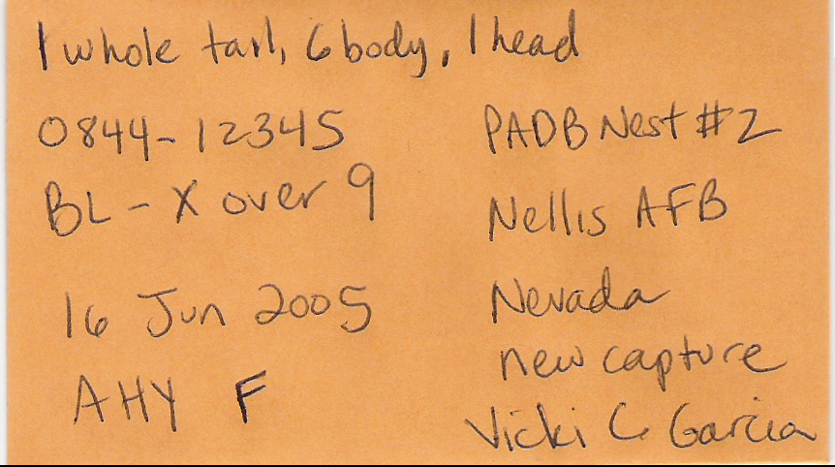

Feather Storage: Store bags with feathers in a refrigerator if possible. If a refrigerator is not available, store feathers in a cool, dry location until ready to send shipment. Contact Courtney Conway at the address below when ready to send collected feathers:

Dr. Courtney J. Conway
USGS Arizona Coop. Fish & Wildlife Research Unit
104 Biological Sciences East
University of Arizona
Tucson, AZ 85721
ph: 520-626-8535
FAX: 520-621-8801
Email: cconway@Ag.Arizona.Edu

