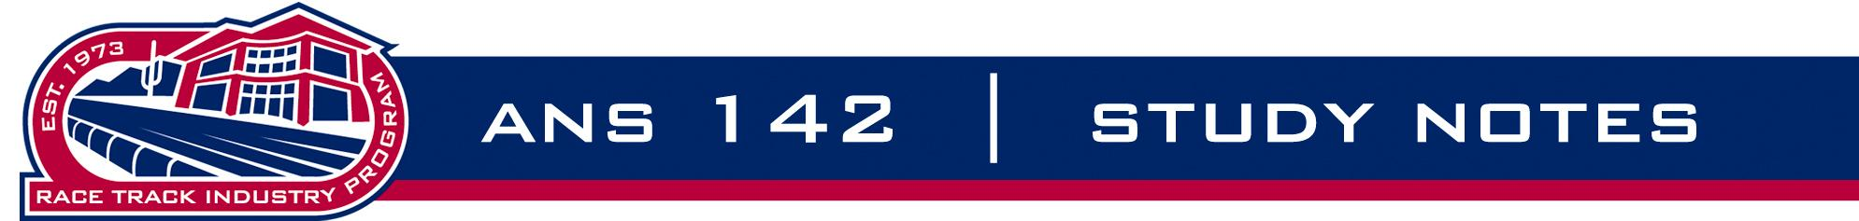

Module 4 – Organizations in Racing

1. Organizations generally fall into the following categories

a. Breed Associations

American Quarter Horse Association
The Jockey Club
United States Trotting Association
The Appaloosa Horse Club
The Paint Horse Association
National Greyhound Association

b. Track Associations

Thoroughbred Racing Associations
Harness Tracks of America
American Greyhound Track Operators Association

c. Horsemen's Association

National Horsemen's Benevolence and Protective Association
(Specific State) Horsemen's Benevolence and Protective Association
Thoroughbred Owners of California
Thoroughbred Horsemen's Association
Almost every state has a specific state breed association i.e. Arizona Thoroughbred Breeders Association

d. Regulatory Associations

Every state with pari-mutuel racing has a racing commission, department of racing, a board or a gaming commission that oversees the rules and regulations of racing i.e. California Horse Racing Board

e. Multi-Purpose Associations

National Thoroughbred Racing Association

2. Most of these will be covered specifically in the appropriate modules.

3. The same types of organizations are found around the world for both greyhound and horse racing.

