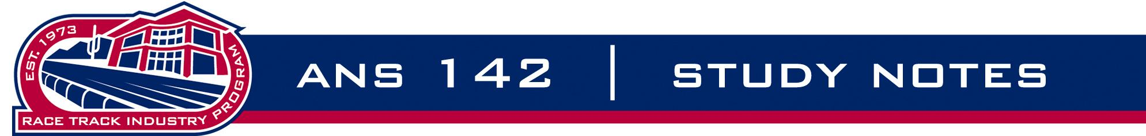

Module 13, 14 – Regulation and Racing Officials

1. Regulatory Structure

2. Regulatory Organizations

3. Stewards are the “major” officials at the track charged with upholding the rules and regulations (and therefore the integrity) of racing.

4. “Minor” officials are all responsible to the stewards and they include (but are not limited to):

Paddock Judge

Patrol Judge

Placing Judge

Identifier

Starter

5. Steward’s Powers

