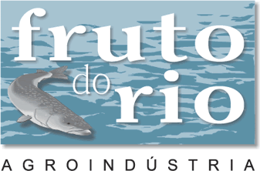

Technical Information

Fruto do Rio Aquaculture is a company based in Santa Maria de Itabira, Minas Gerais, a beautiful region with abundant natural resources, located 130 kilometers outside of the city of Belo Horizonte, and traversed by one of the country’s most important highways.

The company’s pisiculture production is 200 tons/month.

Cultivation System

Breed: Orochromis niloticus
Common name: Tilapia

The intensive cultivation system is comprised of floating river cages measuring 3m x 30m x 1.5m and with the water capacity of 250 units/m3. The cages, which are acquired from a company that specializes in the production of alevins, are airlifted from the Paraná region to the airport in Belo Horizonte.

When the alevins are acquired they weigh approximately 0.5 grams. They are placed in plastic bags containing oxygen and are then packed in cardboard boxes to be moved from Belo Horizonte to the cultivation site. Upon arrival at Fruto do Rio, the alevins receive immediate care in order to adjust to the climatic conditions of the river cages.

The cultivation process involves three stages:

During the first stage, Stage A, approximately 15,000 alevines are kept in each 13m³ cage until the reach the average weight of 15 grams. As they mature, and move from State A to Stage B, the fish are separated, by size, into two homogenous lots (one cage for the bigger fishes and another for the smaller fishes). Depending upon the survival rate, the number of fish in each cage varies from 7,000 to 7,500. They remain in these conditions until the reach the approximate weight of 50 grams.
During the third and final stage, Stage C, the fish are once again divided into two different cages containing two separate lots (one for the bigger fish and another for the smaller ones) so that we now have four cages containing approximately 3,000 to 3,500 units each. By the end of this final stage each weighs an average of 700 grams. On a weekly basis an enough number of alevins are stocked in river cages in order to obtain a production of 200 tons every 210 days.

Cultivation Control

The physical and chemical properties of the water are critical to the success of Fruto do Rio production. In order to carefully monitor the water conditions, the following items are regularly analyzed: water temperature (measured daily); pH level (measured weekly); ammonia levels, alkalinity and hardness (measured weekly); water transparency (monitored weekly).

The Fruto do Rio staff have sufficient training to monitor and oversee all of the various stages of production, including to the maintenance of optimal water conditions and the feeding and slaughtering of the Tilapia, in order to guarantee maximum production output and the highest quality product.

